Low Level Design (SEARCH JOBS BY Qualification MODULE)

Project Code | Team2
Project Name | Online Recruitment Management System

Prepared/Modified by | Role | Date of Preparation
Akash Bansal | Senior Software Analyst | 11/11/2017
Reviewed by | Role | Date of Review
Vaishali Srivastava | Consultant | 16/11/2017
Approved by | Role | Date of Approval
Vishal Mali | Senior Consultant
Circulation List | akash.bansal@capgemini.com,  mvallamk@capgemini.com,  kaustav.saha@capgemini.com,  mohit.deshmukh@capgemini.com | Version Number of the template:1.0
Version Number | 1.3

Table of Contents

1. Description Of The Unit 3
2. References 4
3. Dependencies / Assumptions 5
4. Class Diagrams 6
5. Sequence Diagrams 7
6. Design Components 8
6.1 List Of UI Components 8
6.2 List Of Design Classes 8
7. Re-Usable Routines/Components 9
8. Messages 10
9. Configuration Files 11
10. Crud Matrix Table 12
11. Data Mapping Matrix 13
12. Action Flow Matrix 14
13. Stored Procedures 15
14. Program Specification / Pseudo Code 16
REVISION HISTORY OF THE WORK PRODUCT 17

Description Of The Unit

The search module is used by candidate to get the job details posted by a company. This module searches the job on the basis of qualification required and shows on the UI.

References

Reference | Description
Repository reference | https://IGTEBLRSVNTNG.igatecorp.com/svn/oct3_Team1
Class Diagram | /Project Documents/Design Documents/HLD/Class Diagrams
URS | /Project Documents/Requirements/Case Study/Ecommerce-grp1 and grp3.doc
UTP | /Project Documents/Test Plan/UTP/Test Cases/Search Module
DB Design | /Project Documents/Design Documents/HLD/DB Design/E-Commerce_GROUP_DBDESIGN.xls

Dependencies / Assumptions

Assumptions:

Database should have the details of that jobs stored in it.

Class Diagrams

Class Diagram

Sequence Diagrams

Sequence Diagram
NA

Design Components

List Of UI Components

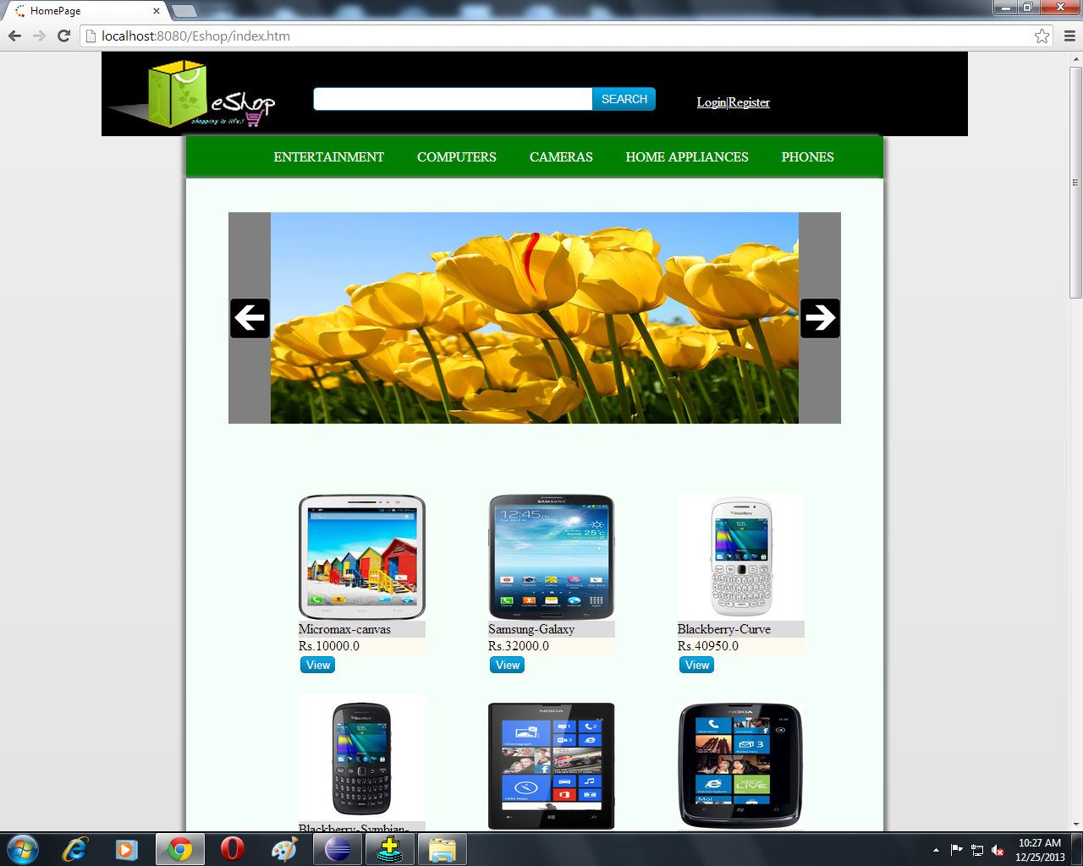

List Of Design Classes

Sr. No. | LLD Name | Class Name | Method Name | Method Description
1 | Search  Jobs by Qualification  Module | Job Requirements | Appropriate getters and setters methods | Getters retrieve the property values and setters set the property values
2 | Search  Jobs by Qualification  Module | RecruitmentController | searchBy(Model model)  byQualifications(@ModelAttribute("jobRequirements") JobRequirements jobRequirements, Model model ) :String | Set attributes to model  Calls getJobByQual() method of RecruitmentServiceImpl class to retrieve JobRequirements satisfying input qualification criteria
3 | Search  Jobs by Qualification  Module | RecruitmentServiceImpl | getJobByQual(String):List | Gets job details, stores in a list and returns it to RecruitmentController
4 | Search  Jobs by Qualification  Module | RecruitmentDAOImpl | getJobByQual(String):List | Gets job details, stores in a list and returns it to RecruitmentServiceImpl

Re-Usable Routines/Components

Re-Usable Routines/Components

- CSS files
- DataAccessException class
- Database xml files
- Logger properties files

Messages

#. | Type | Message Text

Configuration Files

File Name | Path | Description
jpaContext.xml | /Development/Source/OnlineRecruitmentSystem/resources | To configure database connection.
web.xml | /Development/Source/OnlineRecruitmentSystem/WebContent/WEB-INF | To configure the bean properties and request mapping.
servlet-config.xml | /Development/Source/OnlineRecruitmentSystem/WebContent/WEB-INF/config | To configure view resolver.
log4j.properties | /Development/Source/OnlineRecruitmentSystem/resources | To configure the logger.

Crud Matrix Table

# | Table Name | Create | Read | Update | Delete
1 | JobRequirements | N | Y | N | N

Data Mapping Matrix

Sr. No. | Screen Label | Field Source | Field Type | Data Type | Max Length | Data Flow | Mandatory
1 | By Qualification | NA | Label | NA | NA | UI | NA
2 | optQualificationRequired | JobRequirements.qualificaitionRequired | SelectBox | Varchar2 | NA | UI | Yes
3 | Seach | NA | Button | NA | NA | UI | NA

Legend
D → UI (Database to User Interface)
UI → D (User Interface to Database)
UI (User Interface Only)

Action Flow Matrix

Sr. No. | Action | Description | Process
1 | On click of  ‘Search’ Button | Displays job details | Details of jobs entered in text box are displayed on the screen.

Stored Procedures

# | Stored Procedure Name  (with Description) | Input/Out Parameters | Type | Size
1. | NA | NA | NA | NA

Program Specification / Pseudo Code

14.1 <ACTION: SEARCH_CLICK>

Pseudo Code:
- Client Side Scripting:
None
- Server Side Scripting:
IF invalid characters entered
Print Info Message M1.

BEGIN
Call searchProductDetails(@RequestParam(value="productName")String productName,Model model) in presentation layer
BEGIN
Call getProductDetailsByName(String productName) in EcommerceBoImpl in service layer
BEGIN
Call getProductDetailsByName(String productName) in EcommerceDaoImpl in database layer
BEGIN
Create query for retrieving details from Product and ProductImage table
Return product details and returns a list
END
Return product details and returns a list to Service Layer
END
Return product details and returns a list to Presentation Layer
END
REVISION HISTORY OF THE WORK PRODUCT

# | Date | Version # | Section Changed | Details of changes made | Approved By
1 | 16/12/2013 | 1.0 | NA | NA | Uma M Ponniamman
2 | 17/12/2013 | 1.1 | List of design classes. | Name of controller is modified to “EshopControleer”. | Uma M Ponniamman
3 | 18/12/2013 | 1.2 | Reusable components,  References,  Data Mapping Matrix. | Reusable Components added.  File name with relative path is added in the references section.  The name of text boxes(screen label is changed). | Uma M Ponniamman
4 | 20/12/2013 | 1.3 | List of design classes, program specification | Signature of classes modified. | Uma M Ponniamman
5 | 24/12/2013 | 1.4 | Configuration files,UI Components | Paths of the configuration files is updated and UI components(Screen Shots) added. | Uma M Ponniamman

